**1**

Query:

select CompanyName from salesLT.Customer

where FirstName = 'James' and MiddleName = 'D.' and LastName = 'Kramer'

Answer:

*Refined Department Stores*

**2**

Query:

select DISTINCT c.CompanyName

from salesLT.Customer c

inner join SalesLT.CustomerAddress ca on c.CustomerID = ca.CustomerID

inner join SalesLT.Address a on ca.AddressID = a.AddressID

where City like 'D%'

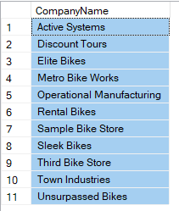Answer:

**3**

Query:

select DISTINCT c.CompanyName, a.AddressLine1

from salesLT.CustomerAddress ca

left join SalesLT.Customer c on c.CustomerID = ca.CustomerID

left join SalesLT.Address a on ca.AddressID = a.AddressID

where AddressType = 'Shipping'

Answer:

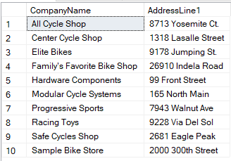

**4**

Query:

select c.CompanyName, o.SubTotal, o.TaxAmt, o.Freight, o.TotalDue

from salesLT.Customer c

inner join SalesLT.SalesOrderHeader o on c.CustomerID = o.CustomerID

where o.TotalDue > 50000

order by o.TotalDue DESC

Answer:

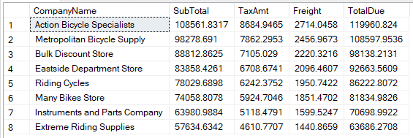

**5**

Query:

select count(*)

from SalesLT.Address a

left join SalesLT.SalesOrderHeader o on a.AddressID = o.ShipToAddressID

left join SalesLT.SalesOrderDetail od on o.SalesOrderID = od.SalesOrderID

left join SalesLT.Product p on od.ProductID = p.ProductID

left join SalesLT.ProductCategory pc on p.ProductCategoryID = pc.ProductCategoryID

where a.City = 'London' and pc.Name = 'Cranksets'

Answer:



**6**

Query:

SELECT A.ListPrice , A.Weight, A.Color, A.ProductID, B.ProductID

FROM SalesLT.Product A, SalesLT.Product B

where A.ListPrice = B.ListPrice AND A.Weight = B.Weight AND A.Color = B.Color and A.Name <> B.Name and A.ProductID < B.ProductID

order by A.ProductID, B.ProductID

Answer:

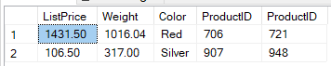

**7**

Query:

select sum(od.OrderQty) as [count], avg(p.ListPrice) as [average]

from SalesLT.Product p

inner join SalesLT.SalesOrderDetail od on p.ProductID = od.ProductID

where ListPrice > 1000

Answer:



**8**

Query:

select pc.Name, sum(p.weight) as [sum_weights]

from SalesLT.ProductCategory pc

inner join SalesLT.Product p on pc.ProductCategoryID = p.ProductCategoryID

group by pc.Name

having sum(p.weight) is not NULL

order by [sum_weights] DESC

Answer:

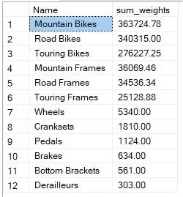

**9**

Query:

select distinct pm.Name, count(p.ProductNumber) as [counter]

from SalesLT.Product p

left join SalesLT.ProductModel pm on p.ProductModelID = pm.ProductModelID

Group by pm.Name

having count(p.ProductNumber) >= 10

Answer:

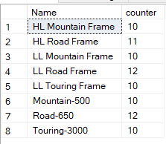

**10**

Query:

with result as (

select top 5 p.Name, sum(od.OrderQty)*p.ListPrice as [Total]

from SalesLT.SalesOrderDetail od

left join SalesLT.Product p on od.ProductID = p.ProductID

group by p.Name, p.ListPrice

order by [Total] DESC)

select * from result

order by result.Total ASC

Answer:

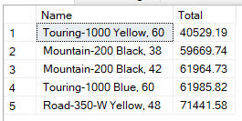

**11**

Query:

select distinct pm.Name, count(p.Size) as [Size]

from SalesLT.Product p

left join SalesLT.ProductModel pm on p.ProductModelID = pm.ProductModelID

Where p.Size = 'XL' or p.Size = 'S'

group by pm.Name

having count(p.Size) > 1

Answer:

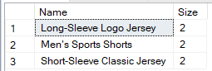

**12**

Query:

select top 1 p.ListPrice, pd.Description

from SalesLT.Product p

left join SalesLT.ProductModelProductDescription pmpd on p.ProductModelID = pmpd.ProductModelID

left join SalesLT.ProductDescription pd on pmpd.ProductDescriptionID = pd.ProductDescriptionID

order by p.ListPrice ASC

Answer:

